**16.2.3 a) –**

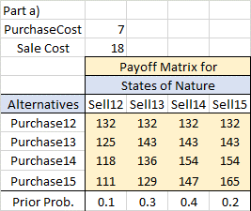

**16.2.3 b) –**

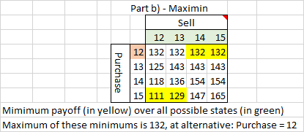

**16.2.3 c) –**

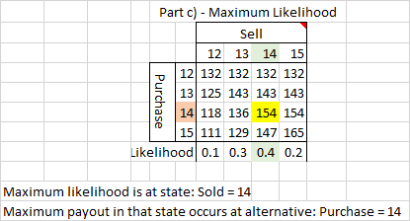

**16.2.3 d) –**

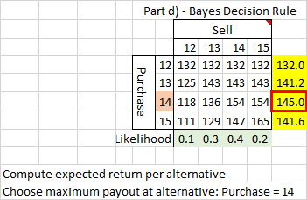

**16.2.3 e) –**

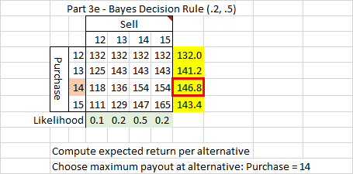

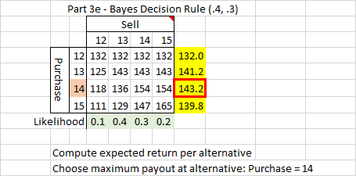

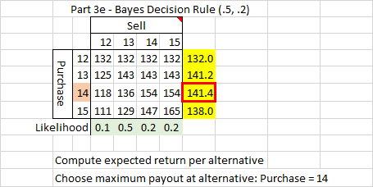

**16.2.5 a)**

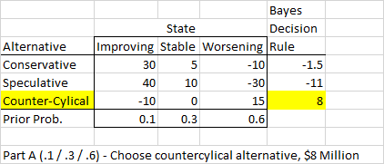

**16.2.5 b) –**

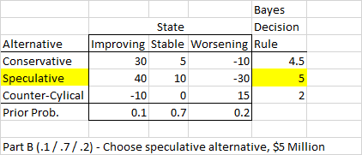

**16.2.5 c) -**

Letting p = the prior probability of a stable economy, and allowing the probability of an improving economy to be fixed at .1 :

Expected[Payoff(Conservative)] = .1(30) + 5(p) – 10(.9-p)

= 3 + 5p – 9 + 10p

= 15p – 6

Expected[Payoff(Speculative)] = .1(40) + 10(p) -30(.9-p)

= 4 + 10p – 27 + 30p

= 40p - 23

Expected[Payoff(Counter-cyclical)] = .1(-10) + 0(p) + 15(.9-p)

= -1 + 13.5 – 15p

= –15p + 12.5

(for line plotting) At p=0 At p = 0.9

Conservative -6 7.5

Speculative -23 13

Counter-cyclical 12.5 -1

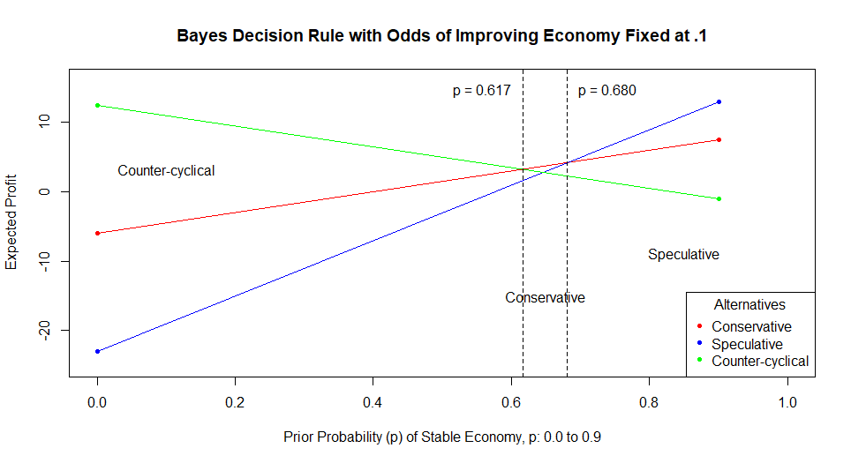

Preferred alternative / maximum payout shifts from Counter-cyclical to Conservative at p = .617

Preferred alternative / maximum payout shifts from Conservative to Speculative at p = .680

**16.2.5 d)** Solve for crossover points:

Initially, Counter-cyclical is best approach (highest expected payout).

Crossover 1 for alternatives ‘Conservative’ and ‘Counter-cyclical’ occurs at:

15p – 6 = -15p + 12.5

30p = 18.5

p = 18.5/30 = .617

Conservative then becomes best approach.

Crossover 2 for alternatives ‘Conservative’ and ‘Speculative’ occurs at:

40p - 23 = 15p – 6

25p = 17

P = 17/25 = .680

Speculative then becomes best approach.

**16.2.5 e)** See graph in part c.

**16.2.6 a) –**

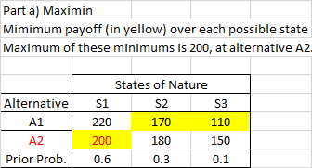

**16.2.6 b)** –

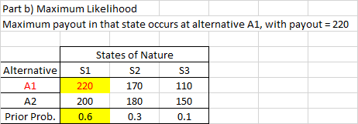

**16.2.6 c)** –

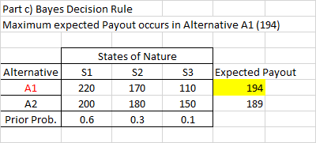

**16.2.6 d)** –

Sensitivity analysis for S1 and S2, holding S3 fixed at a prior probability of 0.1.

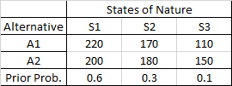

A1 = 220p + 170(.9 – p) + 110(.1)

= 220p + 153 – 170p + 11

= 50p + 164

A2 = 200p + 180(.9 – p) + 150(.1)

= 200p + 162 – 180p + 15

= 20p + 177

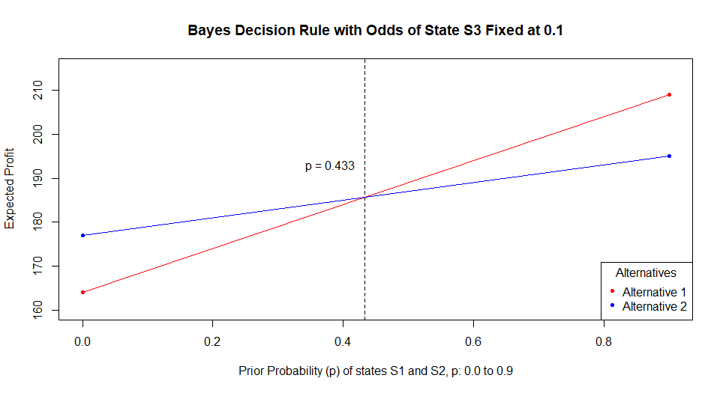 At 0 At 0.9

A1 164 209

A2 177 195

Solve for crossover: Expected[P(A1)] = Expected[P(A2)]

50p + 164 = 20p + 177

30p = 13

p = 13/30, or .433

**16.2.6 e)** – Sensitivity analysis for S1 and S3, holding S2 fixed at a prior probability of 0.3.



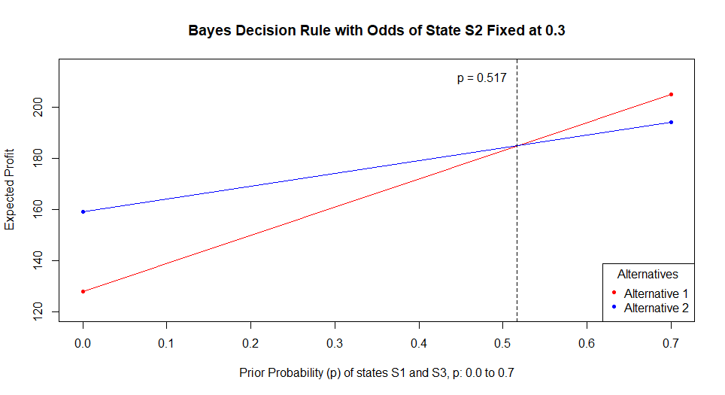A1 = 220p + (.3)170 + 110(.7 - p)

= 220p + 51 + 77 – 110p

= 110p + 128

A2 = 200p + (.3)180 + 150(.7 – p)

= 200p + 54 + 105 – 150p

= 50p + 159

At 0 At 0.7

A1 128 205

A2 159 194

Solve for crossover:

Expected[P(A1)] = Expected[P(A2)]

110p + 128 = 50p + 159

60p = 31

p = 31/60, or .517

**16.2.6 f)** – Sensitivity analysis for S2 and S3, holding S1 fixed at a prior probability of 0.6.



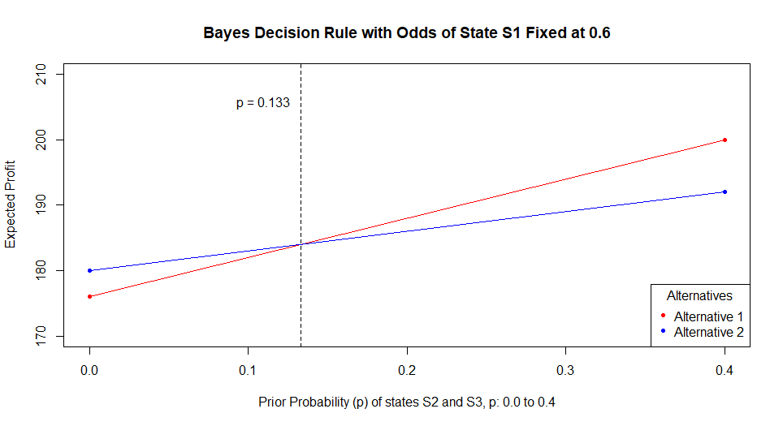

A1 = (.6)220 + 170p + 110(.4 - p)

= 132 + 170p + 44 – 110p

= 60p + 176

A2 = (.6)200 + 180p + 150(.4 – p)

= 120 + 180p + 60 – 150p

= 30p + 180

At 0 At 0.4

A1 176 200

A2 180 192

Solve for crossover:

Expected[P(A1)] = Expected[P(A2)]

60p + 176 = 30p + 180

30p = 4

p = 4/30, or .133

**16.2.6 g) –** Alternative 1

**16.2.7 a) –**

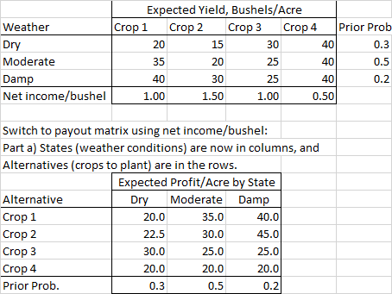

**16.2.7 b) –**

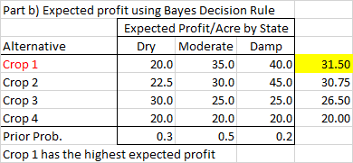

**16.2.7 c) –**

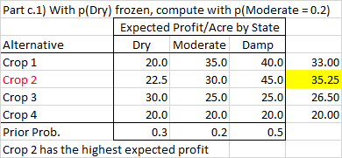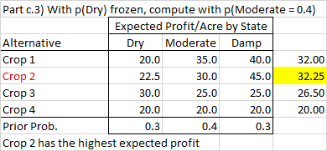

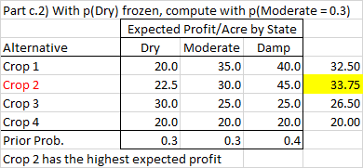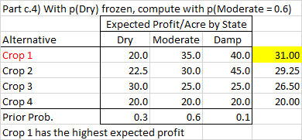

**16.3.7)**

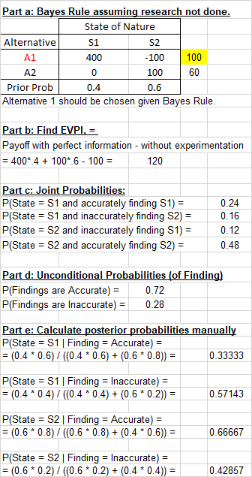

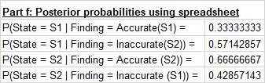

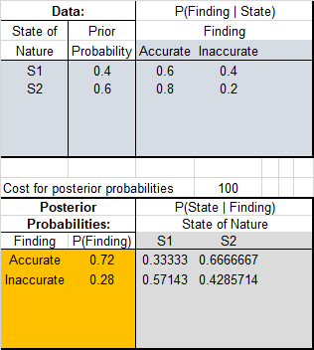

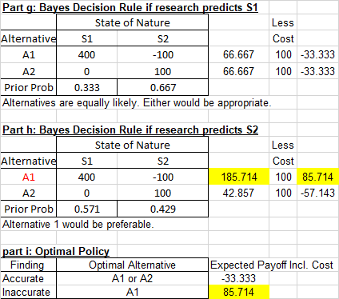

**16.3.12)**

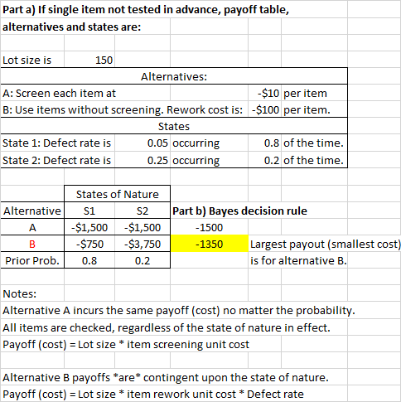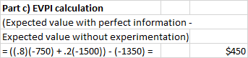

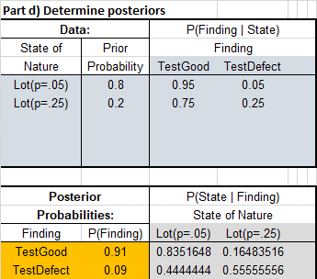

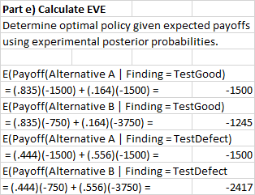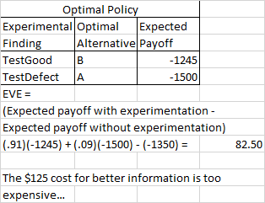

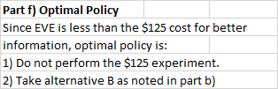

**16.3.14 a) Finding Expected payoffs using Bayes’ decision rule and decision trees for each of the potential guesses (0, 1, or 2 heads):**

If 0 heads guessed, expected payoff is: 100(.2)(.2)(.5) + 100(.6)(.6)(.5) = 20



If 1 head guessed, expected payoff is: 100(.8)(.2)(.5) + 100(.2)(.8)(.5) + 100(.6)(.4)(.5) + 100(.4)(.6)(.5) = 40



If 2 heads guessed, expected payoff is: 100(.8)(.8)(.5) + 100(.4)(.4)(.5) = 40



Either 1 or 2 heads chosen yields the same expected payout (40).

**16.3.14 b)**

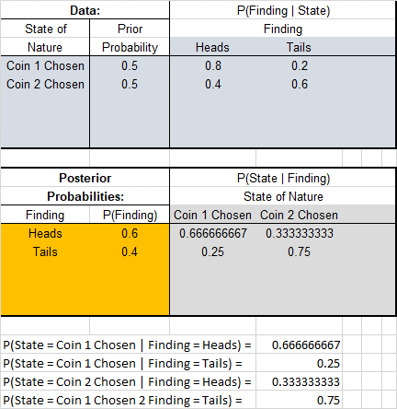

**16.3.14 c) Optimal prediction after watching practice toss:**

If 0 heads guessed, expected payoff is: 100(.6)(1/3)(1/3) + 100(.4)(.75)(.75) = 6.67 + 22.50 = 29.17



If 1 head guessed, expected payoff is: 100(.6)(2/3)(1/3) + 100(.6)(1/3)(2/3) + 100(.4)(.25)(.75) + 100(.4)(.75)(.25) = 13.33+13.33+7.5+7.5 = 41.67



If 2 heads guessed, expected payoff is: 100(.6)(2/3)(2/3) + 100(.4)(.25)(.25) = 26.67 + 2.5 = 29.17



The optimal prediction is to guess that one head will be flipped (expected payoff = 41.66).

* + 1. **d)** EVE =Expected payoff with experimentation – expected payoff without experimentation

41.66 – 40 = 1.66

Optimal policy if $30 must be paid for the coin flip (results in the bottom sections having net $70 payouts instead of $100 payouts, and net $-30 payouts instead of $0 payouts:

1. Choose not to do the coin flip
2. Choose 1 or 2 heads (as both have a $40 payout).

**16.4.3)**

.4

2500

**580**

.6

closed

**900**

-700

.2

**820**

.8

900

**820**

closed

800

750

Optimal policy closes off the choices from the decision nodes at the very top and bottom of the decision tree.